Programming Course Project Report
GitHub Repository Link and Installation Steps
https://github.com/iremsvm/Pinkulator

Installation Steps
- Go to the GitHub repository and click on Code > Download ZIP, or use Git to clone the project:
- Open the project in an IDE that supports JavaFX, such as IntelliJ IDEA.
- Make sure you have:
  - Java Development Kit (JDK 17 or later) installed.
  - JavaFX SDK properly configured in your project libraries and VM options.
- Locate the Main.java file under the src folder.
- Run Main.java to start the application.
- The application will launch with the Login / Register screen.
Calculator Application (Pinkulator)
Group Members:
Betül Varol – Student no: 23040102064 SİGN:
İrem Sevim – Student No: 23040102076 SİGN:
Project Introduction
In this project, modern calculator application called "Pinkulator" was developed using JavaFX. The application allows users to quickly and easily perform basic arithmetic operations while tracking their calculation history.
The application starts with a secure login and registration screen. After logging in, users can perform addition, subtraction, multiplication, and division. All operations are recorded in a user-specific Calculation History section and securely stored on the local disk.
Pinkulator is a comprehensive application that combines basic calculator functions with advanced features such as user authentication and history management.
Key Features of the Application
User Login and Registration System
Each user logs in with a unique username and password. Registrations are temporarily stored in memory.
Basic Calculation Functions
Supports addition (+), subtraction (-), multiplication (×), and division (/).
Clear ("C") to reset, and Delete ("D") to remove the last character are also available.
User-Specific Calculation History
Each user can see their own calculation history displayed at the bottom of the screen.
Aesthetic and User-Friendly Interface
A pink theme with large buttons for easy use, providing a simple and clear design.

Features That Differentiate the Application
Data mix-up between users is prevented.
Access to the calculator without logging in is not possible.
Users’ calculations are recorded instantly.
The colorful and simple interface design prioritizes user experience.

Feature | Successfully realized (Yes or No) | Source code file names
Basic functionality | YES | Main.java
Authentication | YES | Main.java , user.java , usermanager.java
File processing | YES | Usermanager.java
Additional features (if any):
1st Additional feature | YES | Main.java , user.java , usermanager.java
2nd Additional feature | YES | Main.java
…..

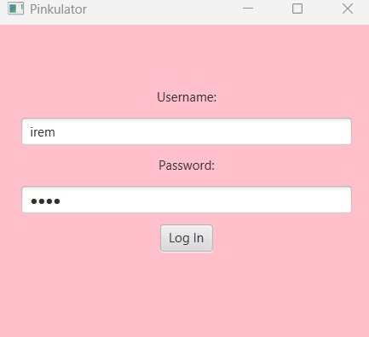
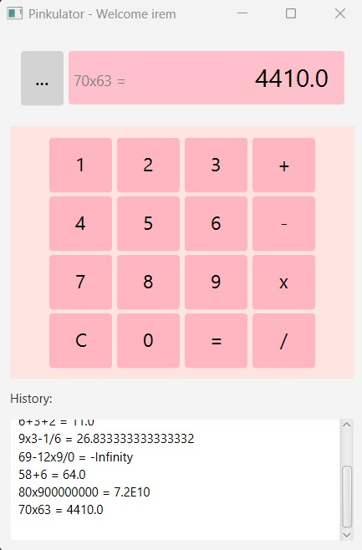
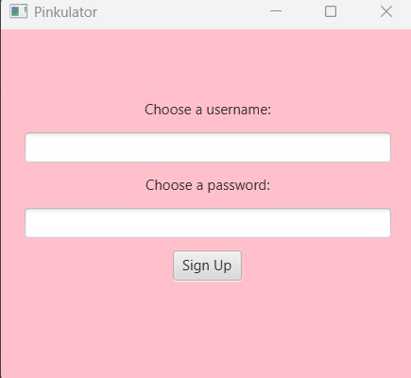
Application Launch Screen Application Launch Screen Calculator interface

